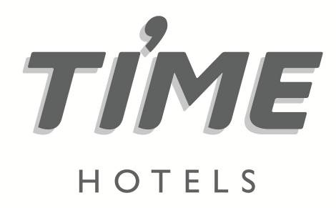

**Press Release**

**For immediate release**

**Hoteliers must embrace digital technology, says TIME Hotels’ Corporate Director of IT**

*An increase in digital-savvy travel consumers has underscored the importance of interacting with customers across every touchpoint of their digital journey*

**Dubai, United Arab Emirates, February 28, 2021:** Contactless technology, upgraded hotel software systems, integrated guest applications, and smart guest rooms are just some of the top technology trends Middle East hoteliers must adopt to attract new and existing customers, according to [Joseph Fayad](https://ae.linkedin.com/in/joseph-fayad), IT Corporate Director of UAE-based [TIME Hotels](https://www.timehotels.ae/).

With research by eMarketer revealing travel consumers spend more time on digital media – 6.41 hours a day compared to 5.30 hours a day for all other media, including TV, radio, newspapers, and magazines, hoteliers now have to implement more defined digital corporate and marketing strategies, as well as more technologically advanced amenities within the hotel room, to stay ahead of the curve.

“COVID-19 has undoubtedly accelerated the need to invest in technology to appeal to today's digitally-savvy online travel consumer. The implementation of immersive technologies that provide guests with virtual 3D tours, apps that allow them to enter their hotel room, change the temperature, call the elevator, book excursions and order room services will be vital in helping hotels recover and stand out from their competitors," said Fayad.

TIME Hotels has undertaken a range of new technology upgrades to appeal to tech guests. These include everything from digital menus and digital in-room collaterals to a mobile app, launched in partnership with hospitality solutions provider Neorcha, that provides the user with room access, room controls, and restaurant and spa bookings.

The hotel management company has also implemented an easy-to-navigate mobile app to capture more direct bookings through a seamless system and capitalise on the increase in guests booking direct via mobile devices.

Guest satisfaction is also addressed through a software tool that allows the guest services team to instantly manage all guest requests and problems by assigning the appropriate department to effectively and efficiently carry out any actions required.

Addressing COVID-19, TIME Hotels has not only launched their Sanitised & Ready protocol in partnership with hygiene solutions provider Diversey, they have also introduced a range of contactless initiatives, which amongst others, includes contactless check-in and check-out.

The company has also revealed plans to implement digital training to ensure team members can steer strategies relating to the digital technology environment.

“Staff training and advancing the careers of those within TIME Hotels has been one of the fundamentals of our success over the years. With a new wave of technology entering the industry, it is imperative we have the people in place to recongnise and implement the changes to stay ahead of the competition,” said Fayad.

For more information, please log onto <http://www.timehotels.ae/>

**ENDS**

**Media contact**

**NATHALIE VISELE**

**Director**



Tel: +971 4 365 2715 | Mob : +971 50 457 6525

E-mail: nathalie.visele@shamalcomms.com

Office 3208, Indigo Icon Tower, Cluster F, JLT

PO Box 502701 | Dubai, United Arab Emirates

Website: [www.shamalcomms.com](http://www.shamalcomms.com)

|  |  |  |  |
| --- | --- | --- | --- |
|  |  |  |  |

**A member of the ECCO Communications Network**

