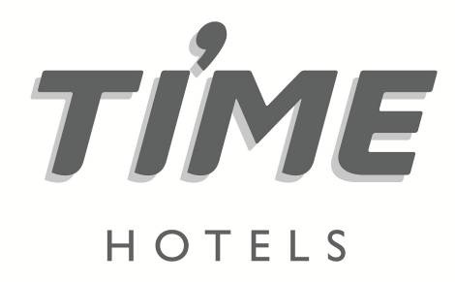

Press Release
For immediate release

TIME Hotels’ ‘Summer Getaway’ deals offer major savings for guests

In addition to booking discounts of up to 35% at selected destinations, summer visitors can save 20% on food, beverages and laundry at TIME Hotels in the UAE and Qatar

Dubai, UAE, 16 June 2022: UAE-headquartered hospitality company, TIME Hotels, is offering major savings for guests staying in the UAE and Qatar through the launch of its ‘Summer Getaway’ deals.

Visitors who book before 15 August will receive discounts of up to 35% on best-available-rate (BAR) prices for stays up to 30 August 2022 at selected TIME Hotels destinations. In addition, guests can take advantage of 20% discounts on food and beverage purchases, as well as laundry services.

With guaranteed early check-in after 10am and late check-out before 4pm, the ‘Summer Getaway’ deals also include complimentary access to TIME Hotels’ fitness and leisure facilities, indoor parking and Wi-Fi.

Mohamed Awadalla, CEO of TIME Hotels, said: “Our ‘Summer Getaway’ initiative has been specifically designed to offer the best possible value for our guests, allowing them to take advantage of the many dining, leisure and fitness facilities on offer at our destinations across the UAE and in Qatar.

“With properties in Dubai, Sharjah and Fujairah, as well as our ever-popular TIME Rako Hotel in Qatar’s Al Wakrah area, our resorts are situated on the doorstep of some of the Middle East’s most popular tourist attractions. With ‘Summer Getaway’ deals available at eight TIME Hotels destinations, we are offering something to suit every taste and budget.”

To celebrate Eid Al Adha, TIME Oak Hotel & Suites’ Waves Pool lounge is offering a ‘BBQ by the pool’ on Sunday, 10th of July. Guests can enjoy delicious BBQ dishes with pool access for AED 125 or AED 99 for just the BBQ.

TIME Onyx Hotel Apartments in Al Qusais, on the other hand, is having an Eid buffet promotion during the first and second day of Eid for just AED 75, which includes pool access and an early bird discount of 20% on the total bill, if reserved in advance.

TIME Moonstone in Fujairah is also offering an Eid buffet on the first day of Eid priced at AED 75. Guests who book for five people will only need to pay for four.

Other summer dining offers available at TIME Hotels’ destinations include Sunday BBQs by the pool, business lunches in Brio, ‘Double Your Pizza’ deals, breakfast buffets, burger and non-alcoholic beer packages, and delicious ‘Life Smoothies’.

The ‘Summer Getaway’ deals are valid at eight TIME Hotels premises in the UAE and Qatar, including: TIME Oak Hotel & Suites, TIME Grand Plaza Hotel, TIME Asma Hotel and TIME Onyx Hotel Apartments in Dubai, UAE; TIME Express Hotel and TIME Ruby Hotel Apartments in Sharjah, UAE; TIME Moonstone Hotel Apartments in Fujairah, UAE; and TIME Rako Hotel in Al Wakrah, Qatar.

Visitors who wish to take advantage of TIME Hotels’ ‘Summer Getaway’ offers simply need to call +971 4 437-7800 or 800HOTELS (within the UAE) or book online at www.timehotels.com/offers/summer-getaway

All prices relating to stays at TIME Hotels destinations are subject to applicable government taxes and fees.

In addition to TIME Hotels’ ‘Summer Getaway’ initiative, visitors can benefit from our ‘advanced purchase deal’. For more information about TIME Hotels, please visit www.timehotels.com.

-ENDS-
Media contact:
NATHALIE VISELE
Director

Indigo Icon Tower, Jumeirah Lakes Towers
Dubai, United Arab Emirates
Tel: +971 4 365 2711 | Mobile: +971 50 457 6525
E-mail: nathalie.visele@shamalcomms.com
Website: www.shamalcomms.com

A member of the ECCO Communications Network

