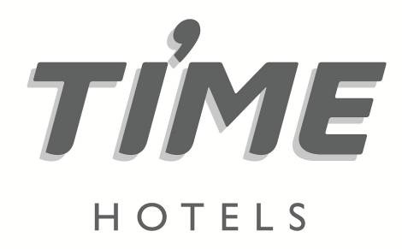

**Press Release**

**For immediate release**

**ESG, technology and affordability top travel trends at ITB Berlin,**

**says TIME Hotels CEO**

**Dubai, United Arab Emirates, March 22, 2023:** According to the CEO of UAE-based [TIME Hotels](https://www.timehotels.com/), Mohamed Awadalla, ESG (Environmental, Social and Governance), technology and affordability were the key travel trends at this year’s ITB trade exhibition, which took place earlier this month, in Berlin, Germany.

Speaking with hundreds of travel professionals during the three-day show, the team from TIME Hotels found that climate change, social responsibility, ethical management, technology and affordability were particularly prominent with Gen Z and Millennial travellers.

“Climate change was clearly the most important issue. Being media savvy generations, we found that they wanted to see tangible evidence that hotels were making a concerted effort to reduce their carbon emissions, whether that is eradicating single use plastics and toiletries, installing LED lighting, water diffusers, recycling efforts, air conditioning modulators or solar panels,” said Mohamed Awadalla, CEO, TIME Hotels.

“Some even went as far as checking if hotels were participating in carbon offset programmes and employing net zero strategies. If hotels want to compete for market share from this demographic, addressing their impact on the environment is essential,” he added.

According to TIME’s executives at ITB, another issue that was very important to Gen Z and Millennial travellers was diversity and inclusion in the workforce. They felt that hotel staff representing different cultures and a management strategy that empowered women, offered guests an enriched experience.

“Obviously, the health and welfare of employees was also of great interest to them, as well as support for local community programmes and charitable donations,” said Awadalla.

Affordability was also a key issue. Although traditionally, the German outbound travel market predominantly has one winter and one summer holiday, younger travellers would rather have more shorter breaks, which are better suited to their work-life balance.

“The younger travellers we spoke to were also more inclined to choose value options, such a four-star hotel, rather than five-star luxury beach resorts, to stretch their annual holiday budget further,” added Awadalla.

The show which attracted over 90,000 participants is one of the largest travel trade events in the world and is considered a key indicator of European traveller trends. Germany is a key source market for Dubai, 422,000 tourists arrived from Germany last year, making it one of the emirate’s top ten source markets. As such, Dubai’s Department of Economy and Tourism (DET) supported a large contingent of the emirate’s hospitality companies at ITB, including TIME Hotels.

“Technology was another area of great interest, but not at the expense of personalised service. They like the convenience of technology especially mobile applications, which can digitalise their journey seamlessly, from the initial reservation right through to check out and their flight home. But they also wanted to engage with members of staff and other guests, to make their stay as enjoyable and informative as possible,” said Awadalla.

TIME Hotels was established in Dubai in 2012 and initially launched with six properties in Dubai and Sharjah, before expanding its portfolio into Saudi Arabia, Qatar, Egypt and most recently Morocco.

“TIME is an independent homegrown brand, built on four main pillars - environmental issues, staff welfare, social responsibility and ethical governance. More than 10% of our existing staff have been with us for over a decade.

“Our success is due to our independence, we have the flexibility to react quickly to market trends and broader social issues,” said Awadalla.

For more information, please log onto <http://www.timehotels.com>

**-ENDS-**

**Photo caption (from left to right):** Mohamed Awadalla, CEO, TIME Hotels at ITB Berlin, with Hosni Abdel Hadi, Chief Executive Officer of Carlton Hotels & Suites and Mohammad Khoori, Managing Director, Golden Sands Hotels.

**Media contact**

**STEVEN JONES**

**Managing Director**



Tel: +971 4 365 2715 | Mob : +971 50 455 9769

E-mail: steven.jones@shamalcomms.com

Office 3208, Indigo Icon Tower, Cluster F, JLT

PO Box 337521 | Dubai, United Arab Emirates

Website: [www.shamalcomms.com](http://www.shamalcomms.com)

|  |  |  |  |
| --- | --- | --- | --- |
|  |  |  |  |

**A member of the ECCO Communications Network**

