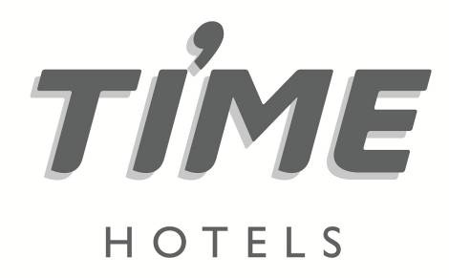

**Press Release**

**For immediate release**

**TIME Hotels announces Middle East expansion plans ahead of ATM 2022**

* *The UAE-based hospitality company will have a portfolio of 21 properties throughout the UAE, Saudi Arabia, Egypt, and Sudan by 2023*
* *The company will outline its ambitious expansion plans next month during Arabian Travel Market 2022*

**Dubai, United Arab Emirates, 27 April 2022:** UAE-headquartered hospitality company [TIME Hotels](https://www.timehotels.ae/) has outlined ambitious expansion plans to increase its portfolio by 40% to 21 properties throughout the UAE, Saudi Arabia, Egypt and Sudan.

The announcement, which comes ahead of the company’s participation at next month’s Arabian Travel Market, which takes place from 9 – 12 May at the Dubai World Trade Centre, will see an additional six properties added to TIME Hotel’s portfolio, with developments in Fujairah, Saudi Arabia, Sudan and three in Egypt being showcased at the Middle East’s premier travel showcase.

Mohamed Awadalla, the co-founder and CEO of TIME Hotels, said: “Following the challenges of the last two years, we have seen unprecedented demand for additional rooms in key territories in the region. This, combined with our in-depth market research, has underscored the need for new, quality-driven, value accommodation.

“We have witnessed resounding success throughout the UAE, Egypt, and Saudi Arabia, and we feel now is the time to expand for the company's future success. With six new properties, totalling 781 keys, this is an important time for our expansion and growth both regionally and internationally.”

As part of the company’s expansion plans, TIME Hotels will expand its offering in the UAE with the launch of the TIME Moonstone Hotel Apartments in Fujairah, located just 10 minutes from a host of amenities, including Fujairah Mall, City Centre Fujairah, and the Fujairah Corniche. The 91-key property, which is scheduled to open on 1 May 2022, will feature 13 one-bedroom and 78 two-bedroom apartments, an all-day dining restaurant, a gym, and saunas and steam rooms.

The company will also expand in Egypt with three new properties, including the 117-key Marina Hotel & Convention Centre on the North Coast, which is expected to open later in Q2 2022. The hotel will have three restaurants, including all-day dining, an Italian and O’Learys Sports Restaurant, as well as a rooftop lounge. Guests will have access to a range of spa facilities, a 750 sqm swimming pool and a gym. The hotel will also cater to the MICE market with a 700-person capacity convention centre.

TIME will also open the 201-key five-star TIME Coral Nuweiba Resorts located on the Red Sea. The resort features five restaurants and a range of amenities, including a private beach, pool, and kid’s facilities and will officially open under the TIME banner in Q3 2022.

The final property in Egypt is the TIME Nakheel Deluxe Apartments, located in the New Capital. The 216-key property is scheduled to open its doors in Q1 2023.

In Saudi Arabia, TIME has unveiled plans to open the 57-key TIME Express Al Olaya in the Saudi capital. The Riyadh property, which will target the budget-conscious traveller, will include a restaurant, a range of leisure amenities and a lively rooftop terrace with a shisha area and dining options.

Rounding out the new openings is TIME’s first foray into the Sudanese market with the TIME Ahlan Hotel Apartments in Khartoum. The 57-key property will be home to a coffee shop, meeting rooms, a rooftop terrace, a swimming pool, a gym, and a juice bar.

“This is an exciting time for the region’s tourism industry and offers a myriad of opportunities for TIME Hotels, not only with these openings but with others that will come further down the line. We have strategically developed a range of brands within our portfolio to offer our guests, whether corporate or leisure, exactly what they want and need from a holiday, business trip or short break,” concluded Awadalla.

TIME Hotels will be exhibiting on stand HC0620 during this year’s Arabian Travel Market.

For more information, please log onto <https://www.timehotels.com/>

**ENDS**

**Media contact:**

**NATHALIE VISELE**

**Director**

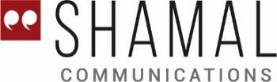

Indigo Icon Tower, Jumeirah Lakes Towers

Dubai, United Arab Emirates

Tel: +971 4 365 2711 | Mobile: +971 50 457 6525

E-mail: [nathalie.visele@shamalcomms.com](mailto:nathalie.visele@shamalcomms.com)

Website: [www.shamalcomms.com](http://www.shamalcomms.com)

|  |  |  |  |
| --- | --- | --- | --- |
| [cid:image002.jpg@01D298CE.BC260960](https://www.facebook.com/shamalcomms/) | [cid:image003.jpg@01D298CE.BC260960](https://twitter.com/shamalcomms) | [cid:image004.jpg@01D298CE.BC260960](https://www.linkedin.com/company/633005) | [cid:image005.jpg@01D298CE.BC260960](https://www.instagram.com/shamalcomms/?hl=en) |

**A member of the ECCO Communications Network**

