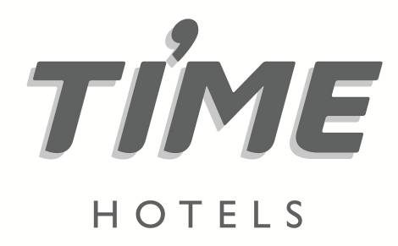

Press release

For immediate release

**TIME Hotels to showcase sustainability credentials at ATM**

* *The hospitality group’s carefully designed exhibition stand has been made from recycled materials*
* *Eco-friendly initiatives including hydroelectric energy will be a main feature*
* *The exhibition stand will be re-used at future editions of ATM*

**Dubai, United Arab Emirates, 25 April 2023:** In keeping with the overarching theme of Arabian Travel Market (ATM) 2023,UAE-headquartered hospitality company [TIME Hotels](https://www.timehotels.com/) will reaffirm its position as a steadfast advocate of sustainability during the four-day regional exhibition. From the design and production of its exhibition stand, to the eco practices on display, TIME Hotels will demonstrate its impressive environmental credentials at ATM 2023.

From a design perspective, the TIME exhibition stand at ATM has been made from recycled materials, with the structure painted with biodegradable paint - a more eco-friendly alternative to toxin-based paints which take longer to break down. LED lighting illuminates the stand, which is more energy efficient and has a longer life span. To minimise the carbon footprint involved in the whole process, materials were delivered to the venue in a single trip.

The stand will be reused at future events for the next three years (for the 2024 and 2025 editions of ATM) and materials will be stored in a sustainably run warehouse. Any materials that are not able to be reused will be taken to licensed recycling centres so that their journey can continue elsewhere.

CEO of TIME Hotels, Mohamed Awadalla commented: “In the past decade, TIME Hotels has successfully implemented a number of market-leading environmental initiatives. We are delighted that sustainability takes the spotlight at ATM 2023 and look forward to sharing the latest news on our environmental practices. We have thought about every detail for our presence at ATM to ensure the sustainable goals and initiatives of TIME Hotels are met onsite.“

Visitors to the TIME Hotels stand at ATM 2023 will be able to learn about the hydroelectric energy and hydroponic farming initiatives at its properties in Egypt and Morocco. Hydroelectric energy is one of the oldest and largest sources of renewable energy, which uses the natural flow of moving water to generate electricity, which can then be stored and used for power. The version showcased is a scaled example of what has been implemented and will also be used to power elements of the stand during ATM.

Outside of ATM, TIME Hotels has implemented various initiatives to support the Net Zero drive. These include the installation of Electric Vehicle (EV) chargers at two of its Dubai properties, joining a Recycle, Reforest, Repeat initiative with the Emirates Environmental Group (EEG), implementing several environmental policies over the past 12 months, such as tracking the amount of gasoline, diesel and LPG consumed to monitor and ultimately reduce its carbon footprint. TIME has also achieved a goal of reducing single-use plastic use by 90% in 2022 and is on target to make this 100% in 2023.

The 30th edition of [Arabian Travel Market (ATM)](https://www.wtm.com/atm/en-gb.html), will run from 1-4 May 2023 at Dubai World Trade Centre (DWTC) and explores the future of sustainable travel in line with its theme, ‘*Working Towards Net Zero*’. Having officially initiated its journey to net zero, this year’s conference programme will explore how innovative sustainable travel trends are likely to evolve, allowing delegates to identify growth strategies within key vertical sectors, while providing a platform for regional experts to explore a sustainable future ahead of COP28, which will take place in November 2023 at Expo City Dubai.

**Arabian Travel Market 2023 takes place from 1-4 May and TIME Hotels is located in Sheikh Saeed Arena Hall Stand HC0625.**

**-Ends-**

**Media contact:**

**STEVEN JONES**

**Managing Director**



Tel: +971 4 365 2715 | Mob : +971 50 455 9769

E-mail: steven.jones@shamalcomms.com

Office 3208, Indigo Icon Tower, Cluster F, JLT

PO Box 337521 | Dubai, United Arab Emirates

Website: [www.shamalcomms.com](http://www.shamalcomms.com)

|  |  |  |  |
| --- | --- | --- | --- |
|  |  |  |  |

**A member of the ECCO Communications Network**

