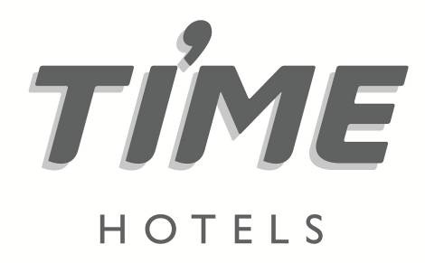

**Press Release**

**For immediate release**

**TIME Hotels implements improved sanitisation protocol ‘Sanitised and Ready’ as industry embraces ‘new normal’**

*Guests can ‘rest assured’ that TIME Hotels complies with the highest standards of cleanliness, as society gradually moves out of COVID-19 lockdown restrictions*

**Dubai, UAE, 9 June 2020:** UAE-headquartered hospitality company, [TIME Hotels](https://www.timehotels.ae/), is set to implement a new and improved sanitisation protocol, ‘Sanitised & Ready’ in partnership with Diversey, a global leading hygiene solutions provider, as the hospitality industry prepares to embrace the ‘new normal’.

In response to the tentative steps being taken to ease the COVID-19 restrictions, TIME Hotels is rolling out the initiative across all of its properties in the UAE, Saudi Arabia and Egypt – with a wide range of new intensified cleaning measures and sanitisation procedures being implemented throughout all public areas as well as in each individual guestroom.

The improved protocol includes detailed infection control which focuses on the disinfection of all hotel transportation, reception areas, elevators, public rest rooms and guestrooms as well as all F&B outlets and kitchens.

[Mohamed Awadalla](https://ae.linkedin.com/in/mohamedawadalla), CEO, TIME Hotels, said: “‘Sanitised & Ready’, which fully complies with all government and public health directives, aims to ensure a safe, healthy and comfortable stay for our valued guests as well as protecting the wellbeing of our dedicated team members.

“As we prepare for the full recovery of the UAE, and indeed, wider MENA region’s hospitality industry this new initiative is being fully embedded into our daily operations, making all increased sanitisation and cleaning measures standard practice rather than just a precautionary measure.”

As part of the new ‘Sanitised & Ready’ protocol, all hard surfaces and areas frequently touched and used by hotel guests including door handles, elevator buttons, reception counters and door frames are being sanitised every 30 to 45 minutes, with a dedicated housekeeping assistant assigned to each individual area.

In addition, and to provide guests with complete peace of mind, once guestrooms are deep cleaned, door locks will be sealed with ‘Sanitised & Ready’ stickers which will be need to be removed by guests before they are able to insert their key into the lock and enter the room.

“An intensified deep clean, sterilisation and disinfection of each of our properties will be completed every quarter, however, individual guestroom sanitisation will be completed on check-out of each guest. As part of the ‘new norm’ hand sanitisers will be available across all public areas, with wet wipe sanitisation kits included within in-room guest amenities,” said Awadalla.

“To ensure our new protocol is strictly adhered to, each team member across all of our properties will participate in practical training courses, with daily follow ups and regular coaching sessions as well as assigning a hygiene officer in every department.”

For more information, please visit [www.timehotels.ae](http://www.timehotels.ae)

**-ENDS-**

**Media contact:**

**NATHALIE VISELE**

**Director**

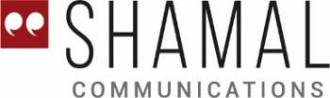

Arjaan Office Tower, Dubai Media City

Dubai, United Arab Emirates

Tel: +971 4 365 2711 | Mobile: +971 50 457 6525

E-mail: [nathalie.visele@shamalcomms.com](mailto:nathalie.visele@shamalcomms.com)

Website: [www.shamalcomms.com](http://www.shamalcomms.com)

|  |  |  |  |
| --- | --- | --- | --- |
|  |  |  |  |

**A member of the ECCO Communications Network**

