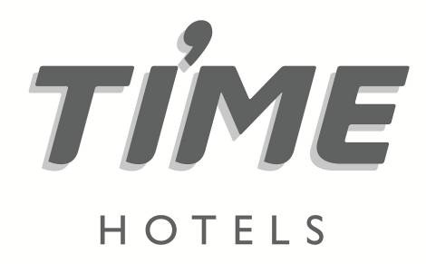

Press release 19 October 2020

For immediate release

**TIME Hotels labeled CSR leader by Dubai Chamber for sixth year in a row**

UAE-headquartered hospitality company, [TIME Hotels](https://www.timehotels.ae/), has added the Dubai Chamber of Commerce & Industry (Dubai Chamber) CSR Label Award for H1 2020, to its growing list of accolades, for the sixth year in succession.

TIME Hotels was recognised for initiatives such as its ‘Sanitised & Ready’ campaign, which includes a range of new intensified cleaning measures and sanitisation procedures which were implemented throughout all public areas as well as in each individual guestroom.

The improved protocol includes detailed infection control which focuses on the disinfection of all hotel transportation, reception areas, elevators, public rest rooms and guestrooms as well as all F&B outlets and kitchens. Additionally, initiatives were put in place to boost morale and promote positive wellbeing among all of its staff members, as well as improving the guest experience across its portfolio of properties.

[Eddie Ignatius](https://www.timehotels.ae/corporate-executives), Corporate Director of Quality & Business Excellence, TIME Hotels, said: “We were applauded by Dubai Chamber’s Centre for Responsible Business for our initiatives and commitment to encouraging and developing CSR plans and activities. To be recognised for the sixth year in a row, not only underscores that commitment to our social responsibilities it also highlights our consistency.

The personal development of all team members is a key focus, with TIME Hotels dedicating a set amount of working hours to allow them to catch up on e-learning modules. Furthermore, through performance-related personal training and development plans, staff are encouraged to broaden their existing skill sets with a range of employee engagement activities.

[Mohamed Awadalla](https://ae.linkedin.com/in/mohamedawadalla), CEO, TIME Hotels, said: “Boosting staff morale is essential during these challenging times and as a result we’re working hard to ensure that we cultivate a warm and constructive working environment, conducive to positive mental health. The current crisis will pass, and I want our staff to be fully motivated when all of the travel and social restrictions have been lifted.”

Launched in 2010 to reward corporate commitment to Corporate Social Responsibility (CSR) initiatives, the CSR Label is awarded based on performance scores across seven different criteria including human resources (training, development, welfare, Emiratisation), client relations, business development, procurement, environment, health and safety, innovation and community; with Dubai Chamber also measuring the resulting impact in four key areas, namely workplace, marketplace, community and environmental.

His Excellency Majid Saif Al Ghurair, Chairman of Dubai Chamber, said: “The benefits of participating in the Dubai Chamber CSR Label initiative are far-reaching and go well beyond the recognition as the framework is designed to help companies evaluate their social and environmental impact and CSR practices, and identify key strengths, as well as areas where they can improve and enhance competitiveness.”

For more information, please log onto <http://www.timehotels.ae/>

**- Ends -**

**Media contact**

**TRINA QUINTANA**

**Account Executive**



Tel: +971 4 365 2711 | Mobile: +971 55 339 6255

E-mail: [trina.quintana@shamalcomms.com](mailto:trina.quintana@shamalcomms.com)

Office 106, Arjaan Office Tower, Dubai Media City

PO Box 502701 | Dubai, United Arab Emirates

Website: [www.shamalcomms.com](http://www.shamalcomms.com/)

|  |  |  |  |
| --- | --- | --- | --- |
|  |  |  |  |

**A member of the ECCO Communications Network**

